Project Report on E-Commerce

By,

A. Balan Vignesh

(Madurai BP Road)

OBJECTIVES

An online e-commerce site which will manage end to end display and sale of its products. Customers to buy products online. Further employees would manage products and orders

**Introduction**

Electronic Commerce is exactly analogous to a marketplace on the internet. Electronic commerce (also referred to as EC, e-commerce) consist primarily of the distributing, buying, selling, marketing and servicing of products or services over electronic systems such as the internet and other computer networks. E-commerce follows – that is, buyers and sellers exchange and transport goods from one place to another. But rather than conducting business in the tradition way-in stores and other “brick and mortar” buildings or through mail order catalogs and telephone operators- in e-commerce buyers and sellers transact business over networked computers.

E-commerce also has some disadvantages, however. Consumers are reluctant to buy some products online. Online furniture business, for example, have failed for the most part because customers want to test the comfort of an expensive item such as a sofa before they purchase it. Consumers also need to be reassured that credit card transaction are secure and that their privacy is respected.

**What do you mean by commerce**

Commerce is the exchange of goods, & services, usually for money. When you nuy something at a score you are participating in commerce. When one things of different ways, he/she immediately recognize several different players of the commerce such as:

**Buyers:** These are the people or organization with money who want to purchase goods and service products.

**Sellers:** These are the people organization that create the products & services that seller’s offer to buyers. Producers may is classified in the category of a seller. They can sell their products to any category to customers.

**What is E-Commerce:**

* It is a business strategy.
* It uses technology to achieve business goals.
* It improves external business relationship.
* It is an evolution in the way companies internet.
* It provides information to facilitate delivery of goods and services.

**User of this System:**

* Administrator
* Customer

Functions done in this project:

* Provide role based access to system.
* Application should be accessible over the internet.
* Customer to perform the following activities:
* Browse the store to view products.
* Browse the store for hot discounted products of the day
* Add and remove products from an online shopping basket.
* Place a shopping order by providing delivery information.
* Provide an authentication mechanism to verify the credential of an employee assigned with the administrator role.
* Provide an authorization mechanism to restrict access to administrative functions based on the fact whether the current user in an administrator or not.
* An admin should be able to perform following activities:

Add new product

Edit information of products.

View status of placed orders.

Update the status of an order to be delivered.

Non Functional requirements:

* Secure access of confidential data (user’s details)

Tools and Technology used in this project:

**Technology**: Bootstrap, Angular JS, Spring MVC, spring security, Hibernate, Web Flows and REST full services.

**Application Server**: Apache Tomcat

**Database:** H2 Database / Oracle Database.

Bootstrap:

Bootstrap is the most popular HTML, CSS, and JavaScript frameworks for developing responsive, mobile-first web sites.

Angular Js:

**AngularJS** is a structural framework for dynamic web apps. It lets you use HTML as your template language and lets you extend HTML's syntax to express your application's components clearly and succinctly. Angular's data binding and dependency injection eliminate much of the code you would otherwise have to write.

Spring MVC:

**Spring MVC** is the web component of **Spring's** framework. It provides a rich functionality for building robust Web Applications. The **Spring MVC** Framework is architected and designed in such a way that every piece of logic and functionality is highly configurable.

Spring Security:

**Spring Security** is a powerful and highly customizable authentication and access-control framework. It is the de-facto standard for securing **Spring**-based applications. **Spring Security** is a framework that focuses on providing both authentication and authorization to Java applications.

Hibernate:

(Hibernate in short) is an [object-relational mapping](https://en.wikipedia.org/wiki/Object-relational_mapping) [framework](https://en.wikipedia.org/wiki/Software_framework) for the [Java](https://en.wikipedia.org/wiki/Java_%28programming_language%29) language. It provides a [framework](https://en.wikipedia.org/wiki/Software_framework) for mapping an [object-oriented](https://en.wikipedia.org/wiki/Object-oriented_programming) domain model to a [relational database](https://en.wikipedia.org/wiki/Relational_database). Hibernate solves [object-relational impedance mismatch](https://en.wikipedia.org/wiki/Object-relational_impedance_mismatch) problems by replacing direct, [persistent](https://en.wikipedia.org/wiki/Persistence_%28computer_science%29) database accesses with high-level object handling functions.

Spring Web flow:

**Spring Web Flow**. **Spring Web Flow**. **Spring Web Flow** builds on **Spring** MVC and allows implementing the "**flows**" of a **web** application. A **flow** encapsulates a sequence of steps that guide a user through the execution of some business task.

Apache Tomcat:

**Apache Tomcat** is an open-source web server and servlet container developed by the **Apache** Software Foundation (ASF). **Tomcat** implements several Java EE specifications including Java Servlet, JavaServer Pages (JSP), Java EL, and WebSocket, and provides a "pure Java" HTTP web server environment for Java code to run in.

H2 Database:

**H2** is a relational **database** management system written in Java. It can be embedded in Java applications or run in the client-server mode. The disk footprint (size of the jar file) is about 1.5 MB

Screenshots:

Home Page

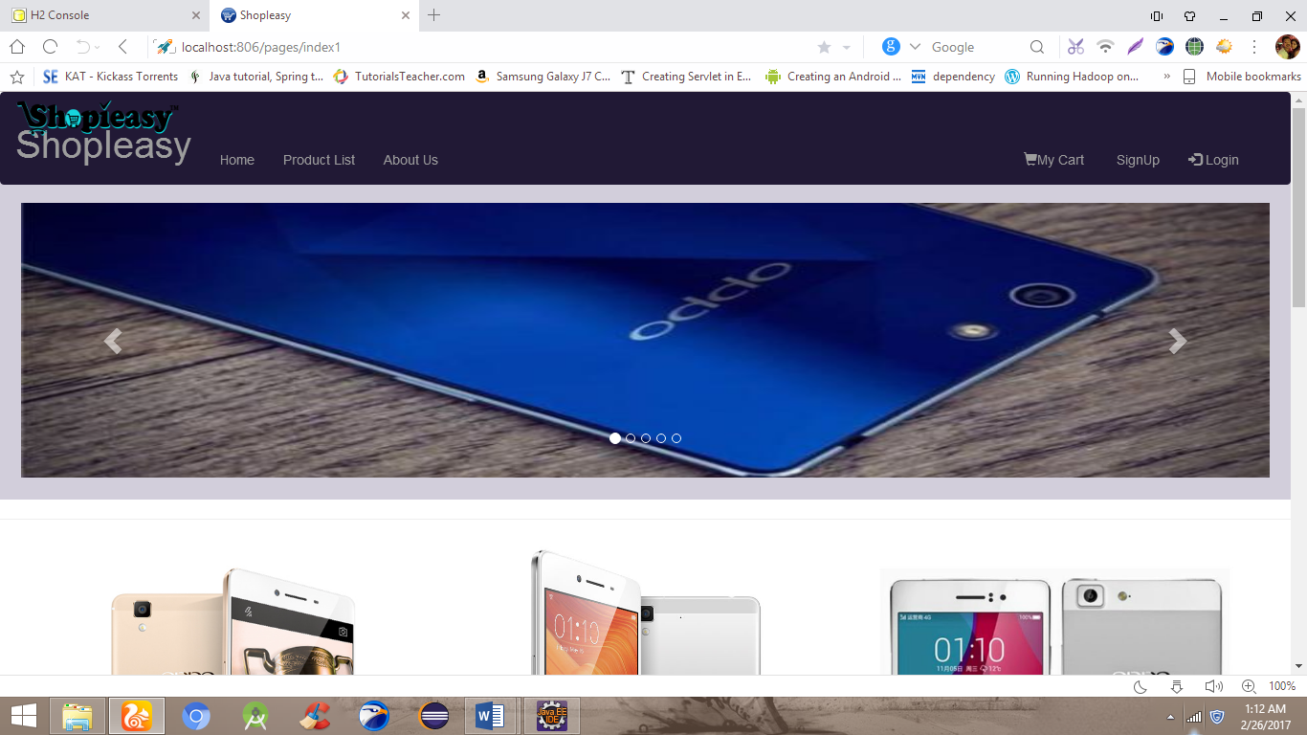

Login Page:

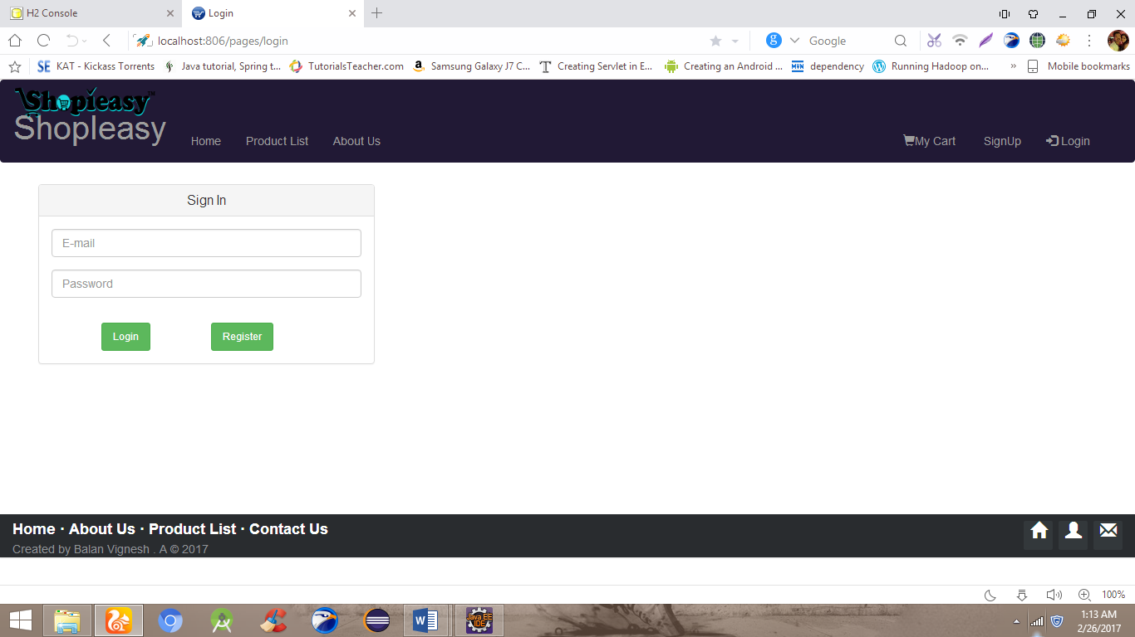

Admin Page:

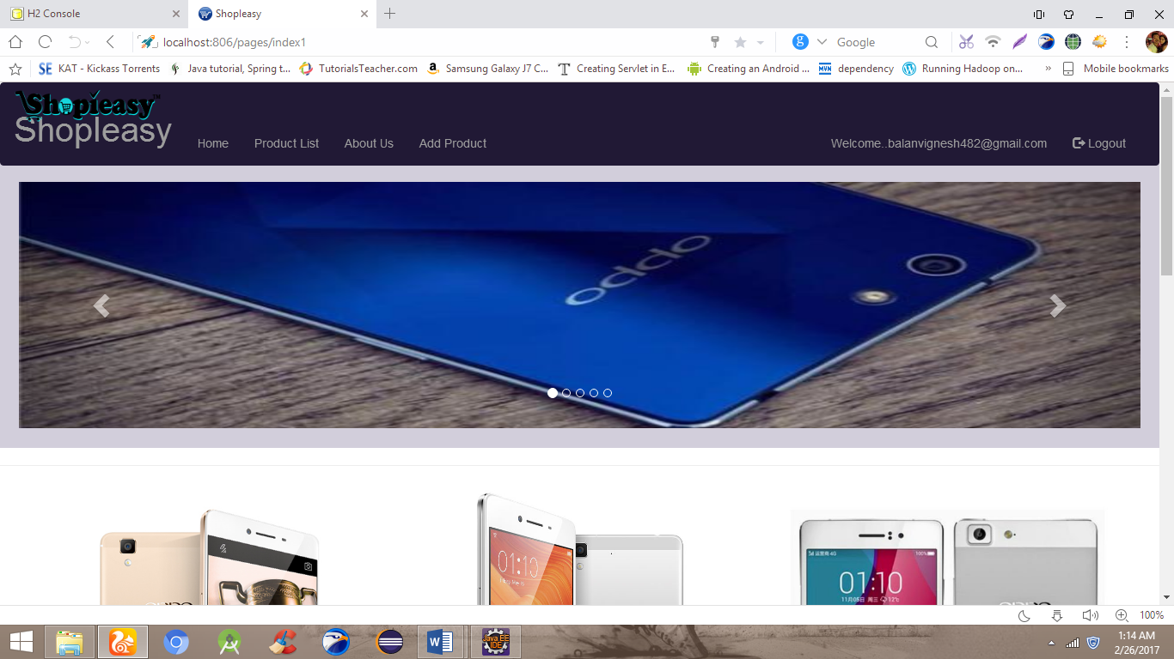

Adding Product:

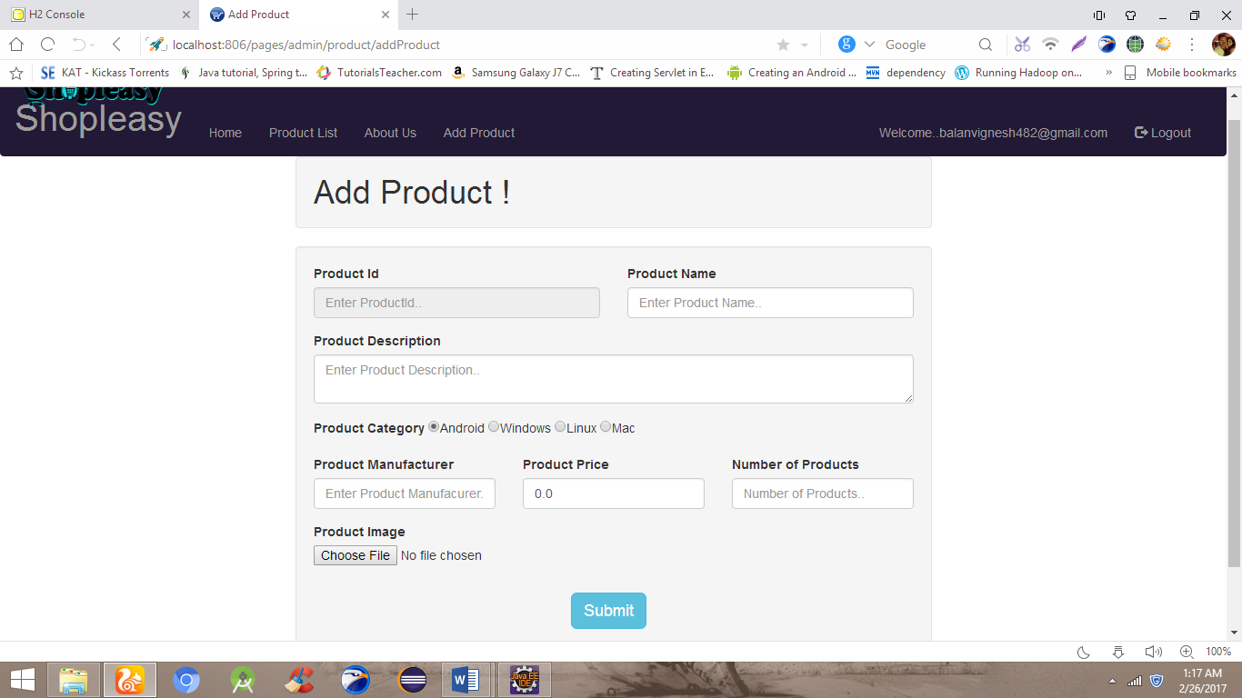

Product Management:

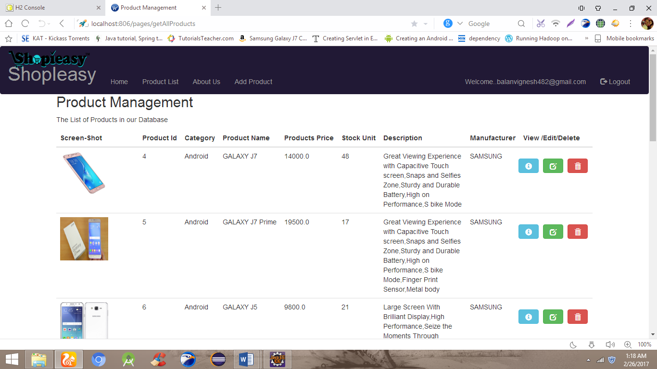

User Page:

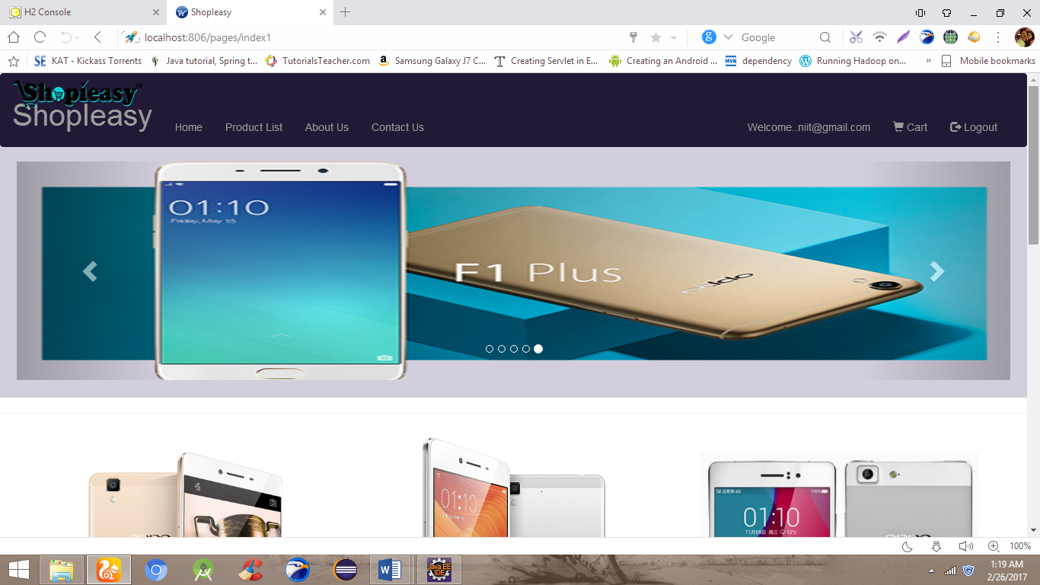

Register:

